CNET Lab Task 3
Task 1:
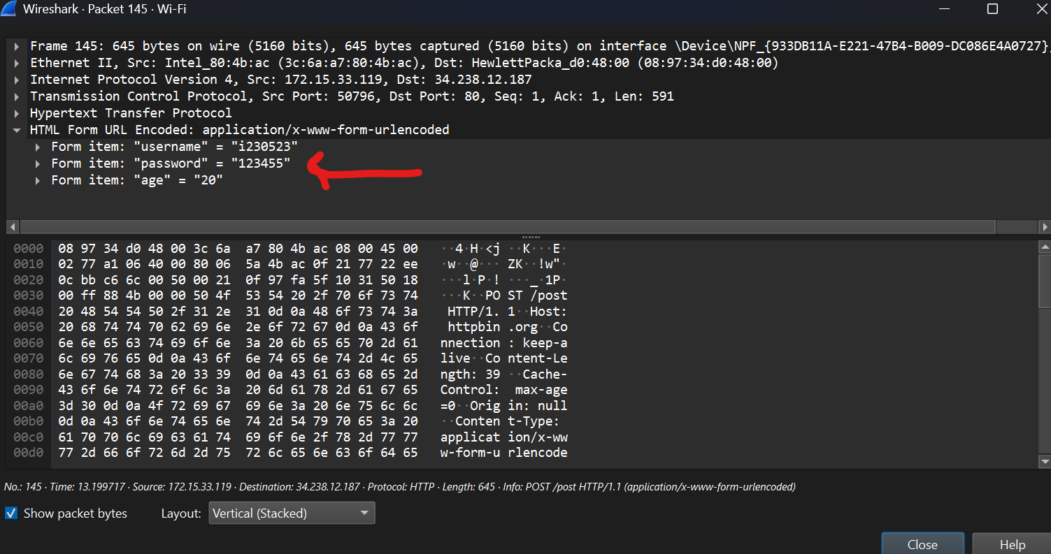
Q1. Why is HTTP considered insecure for transmitting sensitive data? Explain the risks of plaintext transmission and how attackers can exploit it.
Ans: HTTP is insecure bcz everything in it is not encrypted so any sensitive data like personal info like password, etc can be seen in text form by anyone. So attackers will be able to see the password easily.

Task 2:
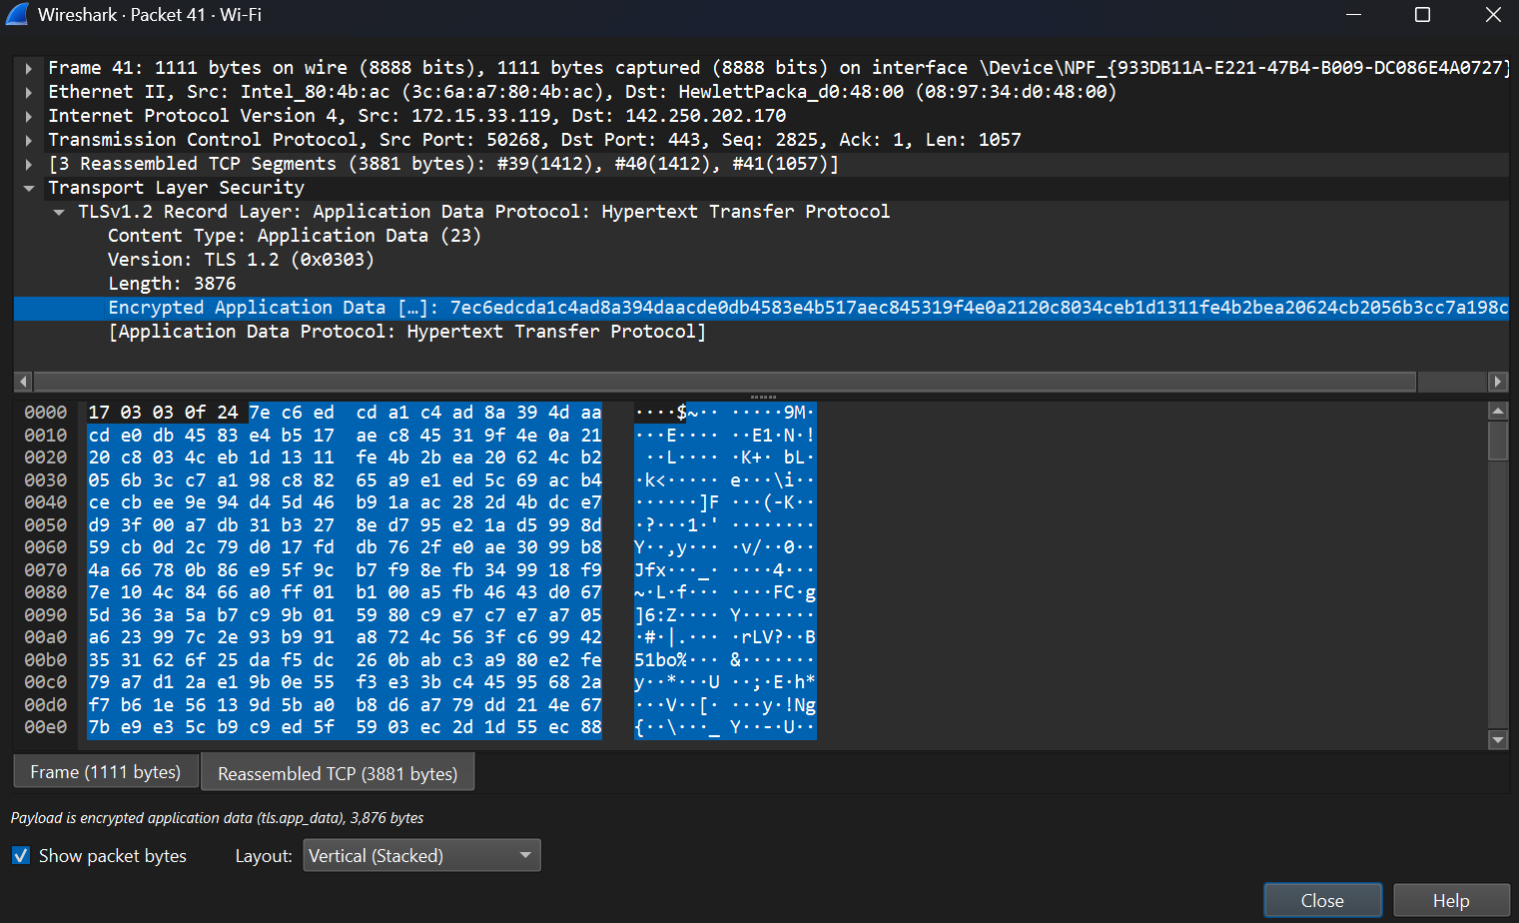
Q1. What differences do you notice between HTTP and HTTPS traffic? Compare the packet details for HTTP vs. HTTPS and note how the data is secured.
Ans: In HTTP, the data of application is all shown in plain text where as in HTTPS, the data is shown all in encrypted form which we can not read.

Q2. Why is HTTPS considered more secure than HTTP? Explain the role of SSL/TLS encryption in preventing data interception and tampering.
Ans: HTTPS is considered more secure than HTTP bcz data in https in encrypted and in http, it is not. The SSL/TLS encrypts the connection between client and server which prevents tampering and interception of data during data transmission.

Task 3:
1. Packet arrival time (timestamp) Arrival Time: Sep 4, 2025 12:39:17.975625000 Pakistan Standard Time
2. Frame length (bytes) Frame Length: 74 bytes (592 bits)
3. Time difference between consecutive packets (inter-packet delay) [first and last request] 12:39:22.032186000 - 12:39:17.975625000 = 4.056561

Q1. How frequently are packets being sent?
Ans: Every 1.02 seconds
Q2. What is the average packet size, and how does it compare to other traffic types? (hint: you will have to generate different traffic)
Ans: Avg packet size of HTTPS is 74 bytes meanwhile of HTTP, it is more than 500 bytes.
Q3. What transmission mode is used?
Ans: N/A

Task 4:
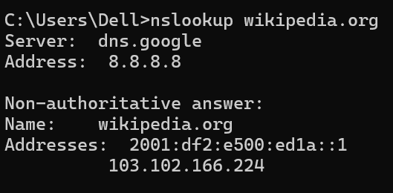
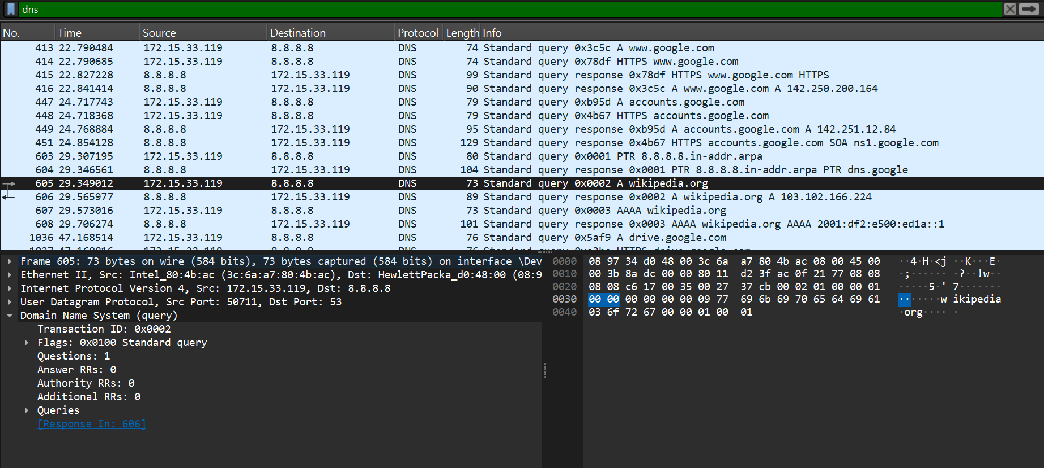
DNS Response Packet

Q1: Why is DNS critical for HTTP/HTTPS communication, and how does it relate to secure data transmission?
Ans: DNS is critical bcz it translates human readable domain names into computer readable domain names, to enable HTTP/HTTPS to reach connection to reach to connect the server successfully, and it does not encypt the ip addresses.

